CHAPTER 1
COMPANY
  - Company Profile
EduPhoenix Solutions is a dynamic and innovative company dedicated to providing cutting-edge solutions in the field of education technology. Established with a vision to revolutionize learning experiences, EduPhoenix Solutions offers a comprehensive range of products and services tailored to meet the evolving needs of educational institutions, students, and educators.
At EduPhoenix Solutions, we leverage the latest advancements in technology to develop intuitive and interactive educational platforms, tools, and resources. Our team of experts is committed to designing and delivering solutions that enhance teaching effectiveness, engage learners, and foster academic success.
From e-learning platforms and virtual classrooms to customized educational software and mobile applications, EduPhoenix Solutions offers a diverse portfolio of products aimed at transforming traditional learning paradigms. We prioritize user-centric design, ensuring that our solutions are user-friendly, accessible, and adaptable to diverse learning environments.

Figure 1.1 Company Logo
In addition to our innovative products, EduPhoenix Solutions provides consultancy services, training programs, and ongoing support to help educational institutions maximize the impact of technology on teaching and learning outcomes. Our collaborative approach enables us to work closely with clients to understand their unique challenges and goals, delivering tailored solutions that drive positive change and innovation.
EduPhoenix Solutions stands at the forefront of educational technology, driven by a passion for innovation and a commitment to excellence. With a deep understanding of the challenges facing modern educational institutions, we offer a comprehensive suite of solutions designed to elevate teaching and learning experiences to new heights.
Our team of experts combines extensive experience in both education and technology to develop cutting-edge platforms and tools that empower educators and engage learners. By harnessing the latest advancements in artificial intelligence, data analytics, and user-centric design, we create intuitive and immersive learning environments that foster creativity, critical thinking, and collaboration.
Beyond our innovative products, EduPhoenix Solutions provides strategic consultancy services and professional development programs to support educational institutions in leveraging technology effectively. From needs assessment and solution design to implementation and ongoing support, we partner with our clients every step of the way to ensure the success of their digital initiatives.
With a strong focus on user experience, accessibility, and scalability, our solutions are tailored to meet the unique needs of diverse educational settings, from K-12 schools to higher education institutions and corporate training programs. By delivering customizable, adaptable, and future-ready solutions, we empower educators to deliver high-quality instruction and empower learners to achieve their full potential in an increasingly digital world.
Driven by a shared vision of transforming education through technology, EduPhoenix Solutions is dedicated to pushing the boundaries of innovation and driving positive change in the education landscape. As we continue to evolve and expand our offerings, we remain steadfast in our commitment to delivering impactful solutions that inspire lifelong learning and shape the future of education.
With a commitment to excellence, integrity, and continuous improvement, EduPhoenix Solutions is dedicated to empowering educators, inspiring learners, and shaping the future of education through technology. We are proud to partner with educational institutions worldwide, helping them unlock the full potential of digital learning in the 21st century.

1.2 Company Overview
EduPhoenix Solutions is a dynamic and forward-thinking company that specializes in providing innovative educational technology solutions to institutions worldwide. Established with a vision to revolutionize the way education is delivered and experienced, EduPhoenix Solutions has quickly emerged as a leader in the field, offering a wide range of cutting-edge products and services tailored to meet the diverse needs of educators and learners alike.
At EduPhoenix Solutions, we believe that technology has the power to transform education by making learning more accessible, engaging, and effective. With this belief at the core of our mission, we strive to develop solutions that empower educators to deliver high-quality instruction and enable learners to reach their full potential.
Our comprehensive suite of products and services encompasses everything from learning management systems and virtual classrooms to interactive content authoring tools and professional development programs. Whether it's providing educators with the tools they need to create immersive learning experiences or offering learners access to dynamic and interactive learning environments, EduPhoenix Solutions is committed to driving positive change in education through technology.
One of the key strengths of EduPhoenix Solutions lies in our team of experts, who bring a wealth of experience and expertise from diverse fields such as education, technology, instructional design, and user experience. By combining our knowledge and skills, we are able to develop innovative solutions that address the evolving needs of the education sector and deliver measurable results.
In addition to our product offerings, EduPhoenix Solutions also provides consultancy services to educational institutions seeking to leverage technology effectively. From needs assessment and solution design to implementation and ongoing support, our team works closely with clients to develop customized strategies and solutions that align with their unique goals and objectives.
As a company, we are deeply committed to excellence, integrity, and customer satisfaction. We take pride in our ability to deliver high-quality products and services that meet the highest standards of quality and reliability. With a customer-centric approach and a focus on continuous improvement, we strive to exceed our clients' expectations and build long-lasting partnerships based on trust and mutual respect.

  - Company Departments
EduPhoenix Solutions operates across several departments, each contributing to the overall mission of delivering innovative educational solutions and services. These departments include:

Human Resources (HR) Department:
Recruitment and Talent Acquisition: This involves identifying staffing needs, sourcing candidates through job postings and recruitment agencies, conducting interviews, and selecting the best-fit candidates.
Employee Onboarding and Orientation: HR ensures that new hires receive necessary training, complete required paperwork, understand company policies, and integrate smoothly into their roles and the organization.
Performance Management: HR oversees performance evaluations, goal setting, feedback mechanisms, and recognition programs to foster employee growth, development, and engagement.
Employee Relations: This department handles employee grievances, conflicts, disciplinary actions, and ensures compliance with employment laws and regulations.
Training and Development: HR designs and implements training programs, workshops, and seminars to enhance employee skills, competencies, and professional development opportunities.
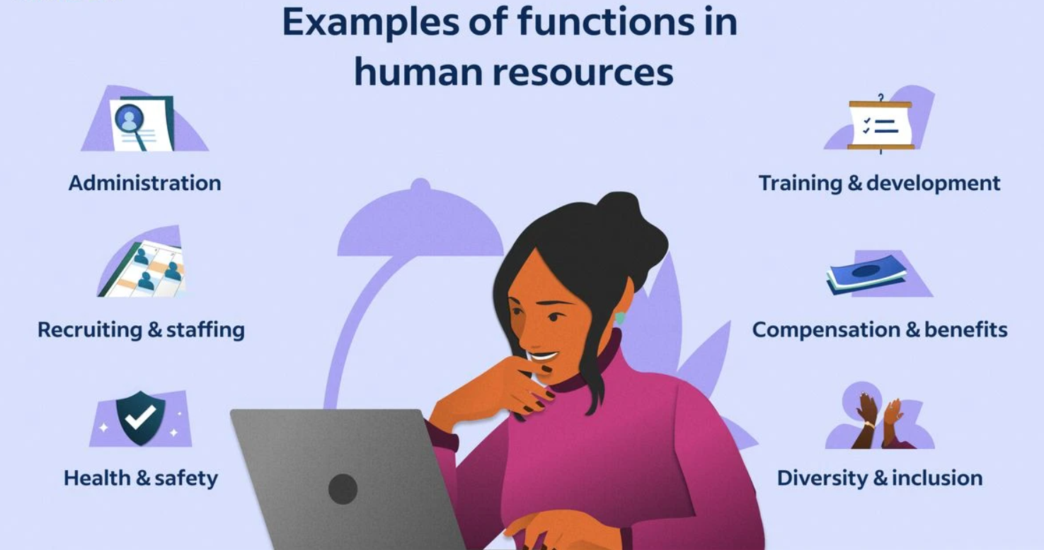
Figure 1.3.1 Functions of Human Resources (HR)

Information Technology (IT) and Technical Support Department:
Infrastructure Management: This includes managing servers, networks, hardware, and software systems to ensure seamless operation, security, and scalability.
Systems Administration: IT administrators monitor system performance, troubleshoot technical issues, install updates, and ensure data backups and recovery protocols are in place.
Cybersecurity: This team protects the organization from cyber threats by implementing firewalls, antivirus software, intrusion detection systems (IDS), and conducting regular security audits and assessments.
Software Development: IT professionals develop and maintain custom software applications, websites, and digital platforms to support internal operations and customer-facing solutions.
Technical Support: The IT helpdesk provides technical assistance, resolves user issues, and offers guidance on software usage, hardware configuration, and network connectivity.
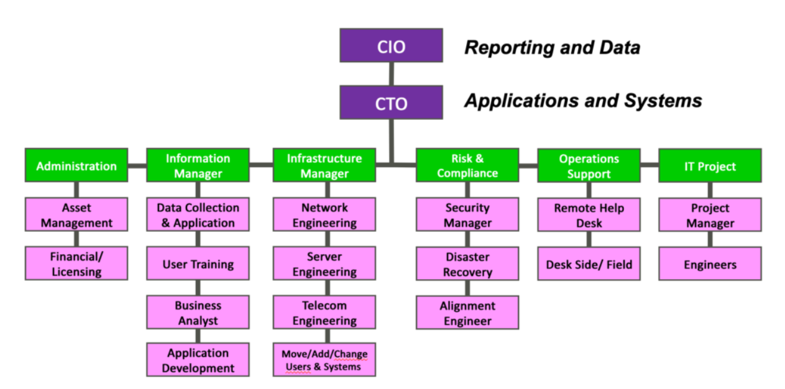
Figure 1.3.2 Information Technology (IT) Department Structure

Research and Development (R&D) Department:
Market Research and Analysis: R&D conducts market research to identify industry trends, customer preferences, and competitive landscapes to inform product development strategies.
Product Innovation: This team conceptualizes and prototypes new products, features, and services, leveraging emerging technologies and customer feedback to drive innovation.
Prototype Development: R&D builds and tests prototypes to validate concepts, assess feasibility, and gather user feedback before full-scale development and commercialization.
Intellectual Property Management: This involves securing patents, trademarks, and copyrights to protect the organization's innovations, inventions, and creative works from infringement.
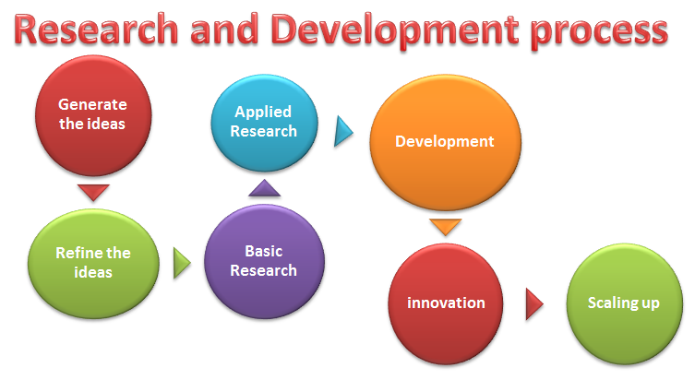
Figure1.3.3 Research & Development Process

Sales and Marketing Department:Market Segmentation and Targeting: Sales and marketing professionals identify and segment target markets based on demographics, behaviors, and preferences to tailor marketing messages and campaigns.
Lead Generation and Nurturing: This team generates leads through advertising, content marketing, and networking efforts, then nurtures those leads through email campaigns, follow-up calls, and personalized communication.
Brand Management: Sales and marketing professionals develop brand identity, messaging, and positioning strategies to differentiate EduPhoenix Solutions from competitors and build brand loyalty.
Digital Marketing: This involves leveraging digital channels such as websites, social media platforms, search engine optimization (SEO), and pay-per-click (PPC) advertising to reach and engage target audiences.
Sales Enablement: Sales enablement teams provide sales reps with the tools, resources, and training needed to effectively communicate product features, benefits, and value propositions to prospects and customers.



Figure 1.3.4(a) Virtual Marketing  Department | Figure 1.3.4(b) Marketing  Department

Customer Success Department:

Customer Onboarding: This involves guiding new customers through the implementation process, providing training, support, and resources to ensure successful adoption and utilization of EduPhoenix Solutions.
Figure 1.3.5 Customer Success
Customer Relationship Management: Customer success managers build and nurture relationships with clients, acting as their advocate within the organization and ensuring their needs and expectations are met.
Account Management: This team is responsible for managing customer accounts, identifying upsell and cross-sell opportunities, and fostering long-term relationships to drive retention and expansion.
Customer Support: The customer support team provides responsive assistance, troubleshooting, and issue resolution to address customer inquiries, technical challenges, and service disruptions effectively.

Finance and Accounting Department:
Financial Planning and Analysis: This department is responsible for budgeting, forecasting, financial modeling, and providing insights to support strategic decision-making.
Accounts Payable and Receivable: Finance professionals manage payments to vendors, invoicing customers, and tracking receivables to ensure timely cash flow management.
Financial Reporting and Compliance: This team prepares financial statements, regulatory filings, and ensures compliance with accounting standards, tax laws, and industry regulations.
Treasury Management: Finance professionals oversee cash management, investment strategies, and risk mitigation to optimize liquidity and financial stability.

Figure 1.3.6 Finance & Accounting

Legal and Compliance Department:
Contract Management: Legal professionals draft, review, and negotiate contracts with clients, partners, and vendors to protect EduPhoenix Solutions' interests and mitigate legal risks.
Regulatory Compliance: This team ensures compliance with laws, regulations, and industry standards related to data privacy, security, intellectual property, and consumer protection.
Intellectual Property (IP) Management: Legal experts manage EduPhoenix Solutions' intellectual property portfolio, including patents, trademarks, copyrights, and trade secrets.
Risk Management: The legal and compliance department identifies, assesses, and manages legal and regulatory risks to minimize exposure and protect the organization from liabilities.

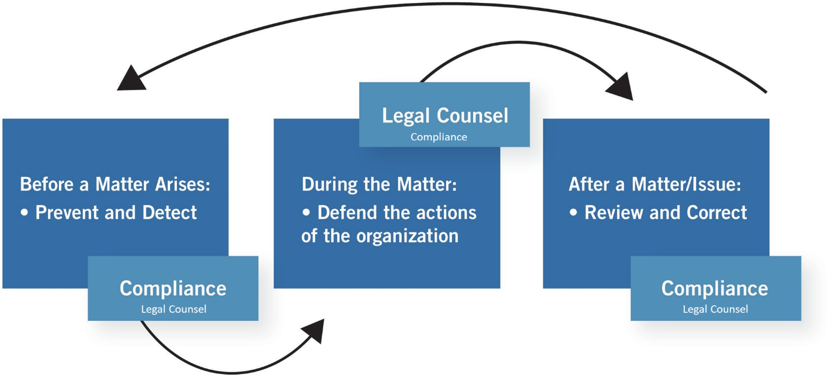

Figure 1.3.7 Legal & Compliance Procedure

Operations and Logistics Department:
Supply Chain Management: Operations professionals oversee procurement, inventory management, and logistics to ensure timely delivery of goods and services while optimizing costs and efficiency.
Facilities Management: This team maintains and manages office facilities, equipment, and infrastructure to create a safe, productive, and comfortable work environment.
Quality Assurance and Control: Operations experts develop and implement quality standards, processes, and metrics to ensure products and services meet or exceed customer expectations.

Figure 1.3.8(a) Operations  Management | Figure 1.3.8(b) Logistics

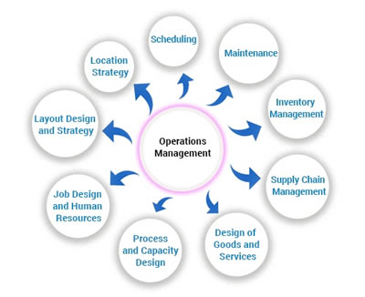

Project Management: Operations professionals coordinate cross-functional projects, allocate resources, and track progress to ensure timely completion and successful outcomes.

Customer Experience Department:
User Experience (UX) Design: This team focuses on designing intuitive, user-friendly interfaces and interactions for digital products and platforms to enhance customer satisfaction and engagement.
Customer Insights and Analytics: CX professionals analyze customer feedback, behavior data, and performance metrics to gain actionable insights and drive continuous improvement initiatives.
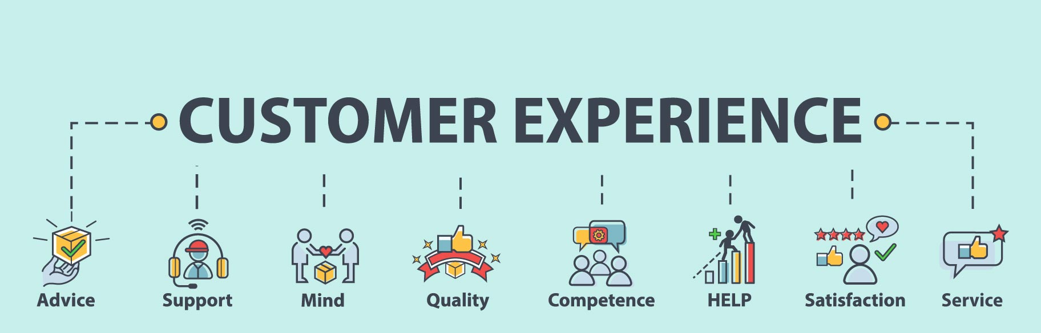
Customer Advocacy: This department represents the voice of the customer within the organization, advocating for their needs, preferences, and concerns to inform product development and decision-making.

Figure 1.3.9 Customer Experience
Customer Satisfaction and Retention: CX professionals develop strategies and programs to measure and improve customer satisfaction, loyalty, and retention rates through proactive engagement and personalized experiences.

Business Development and Partnerships Department:
Strategic Partnerships: Business development professionals identify and cultivate strategic alliances, joint ventures, and partnerships with other companies to expand market reach, access new resources, and drive growth.

Market Expansion: This team explores new markets, geographies, and customer segments to identify growth opportunities and develop market entry strategies to capitalize on emerging trends.
Channel Development: Business development experts establish and manage distribution channels, reseller networks, and affiliate programs to extend EduPhoenix Solutions' reach and increase sales volume.
Competitive Intelligence: This department monitors competitors' activities, market trends, and industry developments to identify threats and opportunities, inform strategic decision-making, and maintain a competitive edge. Figure 1.3.10 Business Development

Quality Assurance and Testing Department:
Quality Assurance (QA) Testing is a critical function that ensures products and services meet specified quality standards before they are released to customers. This involves systematically testing various aspects of software, hardware, or other deliverables to identify defects or areas for improvement.
QA testers develop comprehensive test plans, scenarios, and scripts based on project requirements and specifications. These documents outline the testing approach, test cases, and expected outcomes for each test scenario.
Different types of testing are performed throughout the development lifecycle, including functional testing, which verifies that the system meets specified functional requirements, and regression testing, which ensures that new changes do not adversely impact existing functionality.

Figure 1.3.11(a) Quality Assurance | Figure 1.3.11(b) Testing

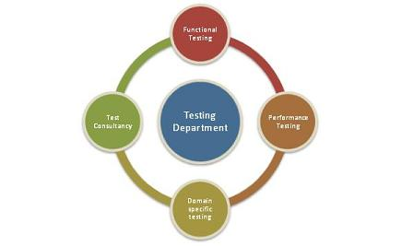
User acceptance testing (UAT) is conducted to validate the product against user expectations and requirements. This involves engaging end-users to evaluate the product's usability, accessibility, and overall user experience.
QA testers use a variety of testing techniques and tools to identify defects and bugs in the system. This may include manual testing, automated testing, performance testing, security testing, and usability testing, among others.
Throughout the testing process, QA testers document their findings, including any defects or issues discovered during testing. They work closely with development teams to prioritize and address these issues, ensuring that high-priority defects are resolved promptly.

Continuous improvement is a key aspect of QA testing, with testers regularly reviewing and refining testing processes and methodologies to enhance efficiency and effectiveness. This may involve implementing new tools, adopting best practices, and incorporating feedback from stakeholders to drive quality improvements.
Grievance and Conflict Resolution Department:
The Grievance and Conflict Resolution department is responsible for managing disputes, grievances, and conflicts within the organization. This department serves as a neutral mediator, helping parties resolve issues in a fair and equitable manner.
One of the primary functions is to provide employees and stakeholders with a platform to express their concerns and grievances. This could involve setting up confidential reporting mechanisms, such as hotlines or online portals, where individuals can raise issues anonymously.
The department investigates complaints and conflicts thoroughly, gathering relevant information and evidence to understand the root causes of the problem. Depending on the nature of the issue, this may involve conducting interviews, reviewing documentation, or engaging in alternative dispute resolution methods like mediation or arbitration.
Once the investigation is complete, the department works towards finding a resolution that addresses the concerns of all parties involved. This could involve implementing corrective actions, revising policies or procedures, or providing training and support to prevent similar issues from arising in the future.
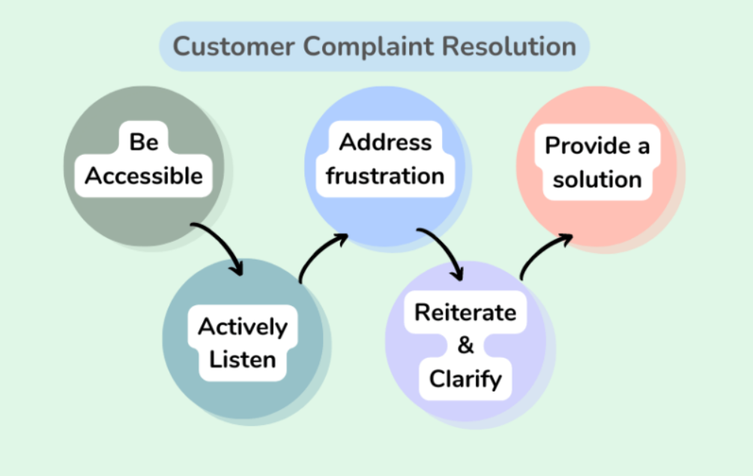
Figure 1.3.12 Customer Complaint Resolution
Additionally, the Grievance and Conflict Resolution department may play a role in promoting a positive organizational culture by fostering open communication, trust, and collaboration among employees. This includes promoting conflict resolution skills and providing resources for managing interpersonal conflicts effectively.

These departments play integral roles in ensuring the success and growth of EduPhoenix Solutions by effectively managing resources, delivering high-quality products and services, and delivers comprehensive educational solutions that empower learners, educators, and institutions to succeed in a rapidly evolving digital landscape.

  - Company Products/Applications
EduPhoenix Solutions prides itself on offering a diverse array of cutting-edge educational technology products and applications designed to cater to the evolving needs of educators and learners alike. Our commitment to innovation and excellence drives us to develop solutions that enhance teaching effectiveness, promote student engagement, and ultimately elevate the learning experience. Here's a detailed overview of our key products and applications:
- Learning Management System (LMS):
Our Learning Management System (LMS) serves as the cornerstone of our educational technology suite. This robust platform provides educators with the tools they need to create, deliver, and manage online courses and educational content seamlessly. With intuitive course creation features, comprehensive content management capabilities, and robust assessment tools, our LMS empowers educators to design dynamic and interactive learning experiences. Moreover, real-time analytics and reporting functionalities enable educators to monitor student progress and performance effectively.

- Virtual Classroom:
In today's digital age, our Virtual Classroom platform offers educators a versatile and immersive online learning environment. Equipped with video conferencing, screen sharing, interactive whiteboards, and chat functionality, this platform facilitates real-time collaboration and interaction between educators and students. Whether conducting live classes, webinars, or virtual workshops, educators can engage learners effectively and foster meaningful learning experiences. Seamless integration with our LMS ensures streamlined course delivery and administration.

- Interactive Content Authoring Tools:
Our suite of interactive content authoring tools empowers educators to create engaging and multimedia-rich learning materials with ease. Featuring user-friendly interfaces, customizable templates, and multimedia integration capabilities, these authoring tools enable educators to develop interactive presentations, quizzes, simulations, and games effortlessly. With built-in assessment and tracking features, educators can assess student comprehension and progress in real time, ensuring that learning objectives are met effectively.

- Professional Development Programs:
Recognizing the importance of continuous professional development, we offer a wide range of training courses and programs designed to enhance educators' skills and knowledge in educational technology and pedagogy. From digital literacy and blended learning to instructional design and technology integration, our professional development programs cover a diverse array of topics. Whether educators are looking to expand their expertise in specific areas or earn certifications in educational technology, our programs provide valuable opportunities for growth and advancement.

- Consultancy Services:
Our consultancy services cater to educational institutions seeking expert guidance and support in leveraging technology for teaching and learning. Our team of seasoned consultants collaborates closely with clients to assess their unique needs, develop tailored technology solutions, and provide ongoing training and support. From strategic planning and needs analysis to implementation and evaluation, our consultancy services empower institutions to maximize the impact of educational technology and achieve their educational goals effectively.

- IoT Projects:
Internet of Things (IoT) projects involve the integration of physical devices, sensors, and software applications to enable connectivity and data exchange. These projects often focus on leveraging IoT technologies to create smart systems, automate processes, and gather insights from real-world data. Eduphoenix Solutions offers a range of IoT projects aimed at providing hands-on learning experiences to students and professionals.
These projects typically cover areas such as:
Sensor Integration: Students learn to integrate various sensors such as temperature sensors, humidity sensors, motion sensors, and environmental sensors into IoT devices and systems.
Data Acquisition and Processing: Projects involve collecting data from sensors and processing it using microcontrollers or single-board computers like Arduino, Raspberry Pi, or ESP8266/ESP32.
Connectivity and Communication: Students explore different communication protocols such as Wi-Fi, Bluetooth, Zigbee, and LoRa to enable connectivity between IoT devices and networks.
IoT Applications: Projects may focus on developing IoT applications for smart homes, smart cities, industrial automation, healthcare monitoring, environmental monitoring, agriculture, and more.
Cloud Integration: Integration with cloud platforms such as AWS IoT, Google Cloud IoT, or Microsoft Azure IoT enables students to store, analyze, and visualize IoT data, as well as implement cloud-based services like remote monitoring and control.
Security and Privacy: Emphasis is placed on implementing security measures such as encryption, authentication, and access control to protect IoT systems from cyber threats and ensure data privacy.

- AI-ML Projects:
Artificial Intelligence (AI) and Machine Learning (ML) projects involve the development and application of algorithms and models to analyze data, make predictions, and automate tasks without explicit programming instructions. These projects harness the power of AI and ML techniques to solve complex problems, optimize processes, and extract insights from data. Eduphoenix Solutions offers a variety of AI-ML projects aimed at fostering understanding and proficiency in these transformative technologies.


Figure 1.4.1 Company Products

Key components of AI-ML projects include:
Data Collection and Preparation: Projects begin with data collection from various sources such as sensors, databases, or web APIs. Data preprocessing techniques are then applied to clean, transform, and prepare the data for analysis.
Algorithm Selection and Model Development: Students explore different AI and ML algorithms such as regression, classification, clustering, neural networks, and deep learning to build predictive models and solve specific problems.
Model Training and Evaluation: The models are trained using abelled data, and their performance is evaluated using metrics such as accuracy, precision, recall, and F1-score. Hyperparameter tuning and cross-validation techniques are applied to optimize model performance.
Deployment and Integration: Once trained and evaluated, the models are deployed into production environments and integrated with existing systems or applications to deliver real-world value. This may involve deploying models on edge devices, cloud platforms, or IoT devices.

Overall, IoT and AI-ML projects offered by EduPhoenix Solutions provide participants with practical experience, critical thinking skills, and technical expertise in emerging technologies, preparing them for careers in the rapidly evolving fields of IoT and AI-ML.

CHAPTER 2
DOMAIN: CYBER SECURITY

2.1 Introduction
Cyber Security is the discipline dedicated to protecting computer systems, networks, applications, and digital data from unauthorized access, misuse, cyberattacks, and disruptions. In today’s digitally driven world, organizations depend extensively on technology for communication, data storage, financial transactions, and operational processes. As digital dependency increases, so does exposure to cyber threats. This makes cyber security not only a technical necessity but also a strategic priority for every organization.
The primary objective of cyber security is to ensure the confidentiality, integrity, and availability of information assets. Confidentiality ensures that sensitive data is accessible only to authorized individuals. Integrity guarantees that data remains accurate and unaltered. Availability ensures that systems and services remain operational and accessible whenever required. Together, these principles form the foundation of secure digital ecosystems.
Modern cyber threats are sophisticated and constantly evolving. Attackers exploit technical vulnerabilities as well as human weaknesses to gain unauthorized access, steal data, disrupt services, or demand ransom. Therefore, cyber security requires a structured understanding of computer systems, networking principles, threat landscapes, defensive technologies, and ethical responsibilities.
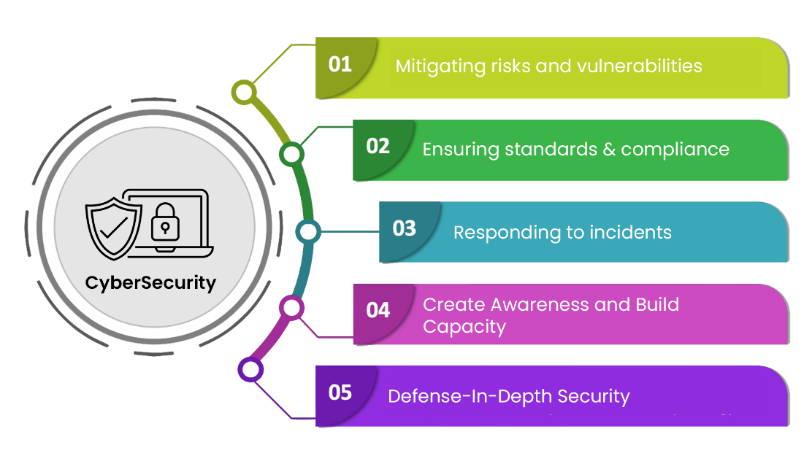
Figure 2.1(a) Cyber Security

The field of cyber security extends across multiple interconnected areas such as network security, operating system security, application and web security, data protection, cryptography, ethical hacking, security operations, and risk management. It integrates both defensive and analytical disciplines, requiring professionals to understand how systems function, how vulnerabilities arise, and how attackers exploit weaknesses. Cyber security specialists develop competencies in areas such as threat analysis, vulnerability assessment, access control implementation, encryption techniques, incident investigation, and security monitoring.
As cyber threats become more advanced and persistent, the need for well-trained cyber security professionals continues to grow significantly. Organizations across sectors—including finance, healthcare, education, government, and technology—actively seek individuals who can identify potential risks, analyze security weaknesses, implement preventive controls, and respond effectively to security incidents. The ability to proactively monitor systems, detect anomalies, and mitigate threats has become essential for safeguarding sensitive data and maintaining operational continuity.
In this rapidly evolving environment, cyber security professionals must continuously update their knowledge to keep pace with emerging attack techniques, evolving technologies, and changing regulatory requirements. By applying structured methodologies, adhering to ethical standards, and utilizing industry-standard security tools and best practices, they contribute to strengthening organizational defenses and ensuring the resilience, reliability, and integrity of digital infrastructures.
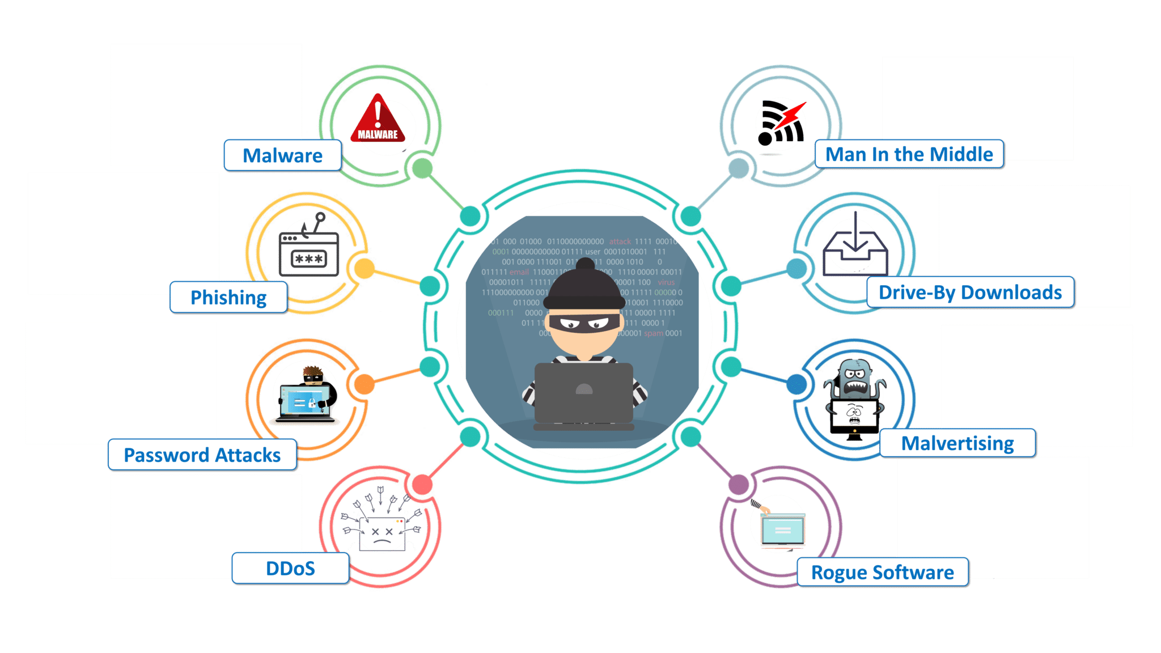
Figure 2.1(b) Introduction to Cyber Security
At EduPhoenix Solutions, our internship program offers aspiring cybersecurity professionals the opportunity to gain hands-on experience in a real-world environment, working alongside seasoned experts to tackle complex security challenges and contribute to the ongoing mission of protecting digital assets and ensuring a secure cyberspace.
2.2 Overview
Cybersecurity plays a critical role in safeguarding digital assets and protecting against cyber threats in today's interconnected world. At EduPhoenix Solutions, cybersecurity is a top priority, ensuring the confidentiality, integrity, and availability of information assets across the organization. The cybersecurity framework encompasses various technologies, processes, and practices aimed at mitigating risks and fortifying the organization's defenses against cyberattacks.
Key elements of the cybersecurity landscape at EduPhoenix Solutions include:
- Security Infrastructure: The organization maintains a robust security infrastructure comprising firewalls, intrusion detection systems (IDS), intrusion prevention systems (IPS), antivirus software, and other security technologies. These tools work together to monitor network traffic, detect suspicious activities, and prevent unauthorized access to sensitive data.
- Policies and Procedures: EduPhoenix Solutions has established comprehensive cybersecurity policies and procedures to govern its security practices. These policies outline guidelines for access control, data protection, incident response, and compliance with regulatory requirements. Regular security awareness training sessions ensure that employees are well-informed about security best practices and their roles in maintaining a secure environment.
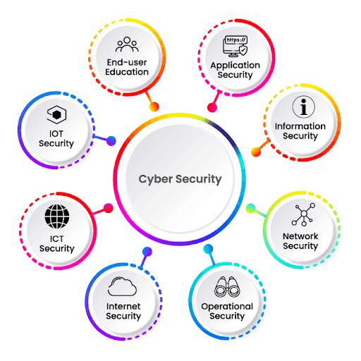
Figure 2.2 Cyber Security Overview
- Incident Response Capability: In the event of a security incident, the organization follows a well-defined incident response plan to effectively mitigate the impact and restore normal operations. The incident response team is trained to identify and respond to security breaches promptly, minimize disruption, and preserve evidence for forensic analysis.
- Threat Intelligence: EduPhoenix Solutions actively monitors the threat landscape to stay abreast of emerging cyber threats and vulnerabilities. By leveraging threat intelligence feeds, security analysts gain insights into the tactics, techniques, and procedures (TTPs) employed by threat actors, enabling proactive threat detection and response.
- Compliance and Regulation: Compliance with industry regulations and data protection laws is integral to EduPhoenix Solutions' cybersecurity strategy. The organization adheres to relevant regulatory frameworks such as GDPR, HIPAA, and PCI DSS, ensuring that data privacy and security requirements are met across all operations.
- Continuous Improvement: EduPhoenix Solutions is committed to continuous improvement in cybersecurity practices, regularly conducting security assessments, penetration testing, and vulnerability scans to identify and address potential weaknesses. Feedback from these assessments is used to refine security controls and enhance overall security posture.
Overall, cybersecurity at EduPhoenix Solutions is characterized by a proactive approach to risk management, stringent adherence to security policies and regulations, and a culture of vigilance and resilience in the face of evolving cyber threats. Through these efforts, the organization remains steadfast in its commitment to protecting its assets, clients, and stakeholders from cyber threats.

2.3 Types of Cyber Attacks
Cyber attacks represent deliberate attempts to exploit vulnerabilities in computer systems, networks, or applications in order to gain unauthorized access, disrupt operations, or compromise sensitive data. Understanding different types of attacks is essential for developing effective defensive strategies and strengthening an organization’s security posture. Based on the cyber security syllabus framework, attacks can be broadly understood in terms of network attacks, web attacks, malware-based threats, and passive reconnaissance techniques.
Cyber attacks are generally categorized into active attacks and passive attacks, depending on whether the attacker directly interferes with system resources or secretly monitors communication.

Active Attacks
Active attacks involve direct interaction with the target system. In these attacks, the attacker attempts to alter data, disrupt services, or gain unauthorized control over resources.
One of the most common forms of active attacks is malware-based attacks. Malware refers to malicious software designed to damage, disrupt, or gain unauthorized access to systems. It can enter systems through infected email attachments, malicious downloads, compromised websites, or removable storage devices. Common types of malware include viruses that attach themselves to legitimate programs, worms that spread across networks without user intervention, Trojans that disguise themselves as legitimate applications, ransomware that encrypts data and demands payment, and spyware that secretly collects user information. Malware attacks can result in data theft, system corruption, and operational downtime.
Another major category of active attacks includes phishing and social engineering attacks. These attacks exploit human psychology rather than technical vulnerabilities. Phishing involves sending deceptive emails or messages that appear to originate from legitimate sources, tricking users into revealing login credentials, financial details, or confidential information. Social engineering techniques may involve impersonation, pretexting, or baiting to manipulate individuals into performing actions that compromise security. Such attacks highlight the importance of user awareness and strong authentication mechanisms.
Denial-of-Service (DoS) attacks are also active attacks aimed at disrupting the availability of services. In a DoS attack, the attacker floods a server or network with excessive traffic, making it unable to respond to legitimate user requests. Variants such as SYN floods, UDP floods, or HTTP floods overwhelm system resources and cause service outages. When performed from multiple compromised systems, it becomes a Distributed Denial-of-Service (DDoS) attack. These attacks primarily target the availability component of the CIA triad.
Within network security, attacks such as spoofing and man-in-the-middle (MITM) attacks are also significant. Spoofing involves falsifying identity information such as IP addresses to gain unauthorized access or bypass security controls. In a man-in-the-middle attack, the attacker intercepts communication between two parties, potentially altering or stealing the transmitted data without their knowledge.

In the context of web security, SQL Injection and Cross-Site Scripting (XSS) are critical application-layer attacks. SQL Injection occurs when attackers manipulate database queries through unsanitized input fields to extract or modify data. Cross-Site Scripting allows attackers to inject malicious scripts into web pages viewed by other users, compromising session data and authentication credentials. These attacks emphasize the need for secure coding practices and input validation.

Passive Attacks
Passive attacks involve monitoring or observing systems without directly altering data or disrupting services. The objective is usually to gather information for future exploitation.
Eavesdropping is a common passive attack in which attackers secretly monitor communication channels to capture sensitive information such as usernames, passwords, or confidential messages. This typically occurs when data is transmitted without encryption.
Packet sniffing is a technique used to capture and analyze network packets traveling across a network. By intercepting unencrypted traffic, attackers can extract sensitive data such as login credentials or private communications. Packet sniffing is particularly dangerous on unsecured public Wi-Fi networks or poorly configured internal networks.
Another passive technique is traffic analysis, where attackers study communication patterns, packet sizes, and timing information without necessarily accessing the actual data content. By analyzing metadata, attackers may infer user behavior, identify critical servers, or understand network architecture. Even when encryption protects data content, traffic analysis can reveal valuable intelligence about system usage and communication flows.

2.4 Cyber Security Tools
Cyber security tools form the practical backbone of modern information security practices. They enable organizations to identify vulnerabilities, monitor network activities, secure applications, protect data, and respond effectively to cyber incidents, these tools can be understood within the broader areas of network security, web security, vulnerability assessment, ethical hacking, and security operations.
Vulnerability assessment tools are designed to identify weaknesses in systems, networks, and applications before attackers can exploit them. These tools automatically scan infrastructure to detect outdated software, misconfigurations, missing patches, and known security flaws. By generating detailed reports, they help security teams prioritize remediation efforts and strengthen the overall security posture. Tools such as OpenVAS are widely used to perform comprehensive vulnerability scans and maintain secure system configurations.
Network scanning and reconnaissance tools play a crucial role in understanding network architecture and identifying exposed services. These tools help discover active hosts, open ports, running services, and potential entry points within a network. For example, Nmap is commonly used to map network structures, perform port scanning, and detect operating systems. Such tools are essential for both defensive security assessments and ethical hacking activities.
Packet analysis and network monitoring tools provide visibility into network traffic. These tools capture and analyze data packets traveling across networks, allowing security professionals to detect suspicious behavior, unauthorized access attempts, or malicious communication patterns. Packet analyzers help in troubleshooting connectivity issues, investigating incidents, and identifying anomalies in real time. They are particularly important in detecting sniffing attacks and monitoring encrypted and unencrypted traffic flows.
Intrusion Detection Systems (IDS) and Intrusion Prevention Systems (IPS) are core components of network defense mechanisms. IDS solutions monitor network traffic and system logs to detect unusual or malicious activities, generating alerts for security teams. IPS solutions extend this functionality by actively blocking or mitigating detected threats in real time. These systems protect against malware, exploitation attempts, and denial-of-service attacks, forming a critical layer in defense-in-depth strategies.
Web application security tools are designed to identify vulnerabilities within web-based systems. Since web applications are frequently targeted by attacks such as SQL Injection and Cross-Site Scripting (XSS), specialized testing tools are required to assess application security. Tools like ZAP (Zed Attack Proxy) assist in identifying input validation flaws, broken authentication mechanisms, and other common web vulnerabilities. SQLMap is specifically used to detect and validate SQL injection vulnerabilities in database-driven applications. These tools support secure coding practices and application hardening efforts.
Ethical hacking and penetration testing tools simulate real-world attack scenarios in controlled environments. They help security professionals assess how an attacker might exploit vulnerabilities. Tools used for reconnaissance, scanning, and exploitation allow organizations to evaluate system resilience and implement corrective measures before actual breaches occur.
Password assessment and authentication testing tools are used to evaluate the strength of authentication mechanisms. These tools simulate dictionary attacks, brute-force attempts, and credential testing processes to identify weak passwords or poor access control policies. Their purpose in professional environments is to strengthen password policies and implement robust multi-factor authentication systems.
Network utility tools such as Netcat and Socat provide flexible communication capabilities for testing, debugging, and secure data transfer. They can be used for port scanning, establishing secure tunnels, and simulating client-server communication. These tools are valuable in both troubleshooting network issues and understanding how attackers might exploit open communication channels.
Cloud security assessment tools focus on identifying misconfigurations and vulnerabilities in cloud environments. As organizations increasingly migrate infrastructure to cloud platforms, such tools help ensure compliance with security standards and best practices, preventing unauthorized access and data exposure.
Security operations tools, including log monitoring and Security Information and Event Management (SIEM) systems, aggregate data from multiple sources to detect suspicious activities. They enable continuous monitoring, real-time alerting, and structured incident response. These tools support proactive defense strategies and help organizations respond efficiently to security incidents.
Overall, cyber security tools are essential for implementing structured defense mechanisms across networks, operating systems, web applications, and data environments. When integrated into a comprehensive security framework, these tools enable continuous monitoring, vulnerability detection, risk assessment, and incident management, thereby strengthening the organization’s ability to prevent, detect, and respond to evolving cyber threats.

2.5 Network Sniffers
Network sniffers, also known as packet analyzers or network protocol analyzers, are cybersecurity tools used to capture and analyze network traffic.
They intercept and inspect data packets as they travel across a network, allowing security analysts to examine the contents of the packets and monitor network communications.
Network sniffers decode network protocols and analyze packet headers and payloads to extract valuable information about network activity.
- Functionality:
Network sniffers operate by placing network interface cards (NICs) in promiscuous mode, allowing them to capture all network traffic passing through a network segment. They capture packets in real-time and store them for analysis, providing insights into network behavior, performance, and security.
Network sniffers can filter captured packets based on specific criteria, such as source or destination IP address, port number, protocol type, or packet content.
- Applications:
Troubleshooting: Network sniffers are used to diagnose network issues, identify network bottlenecks, and troubleshoot connectivity problems by analyzing packet traces.
Security Monitoring: Security analysts use network sniffers to detect and investigate security incidents, such as unauthorized access attempts, malware infections, and data breaches.
Network Forensics: Network sniffers aid in forensic investigations by capturing and analyzing network traffic to reconstruct events, identify attack patterns, and gather evidence for legal proceedings.
Performance Monitoring: Network administrators utilize network sniffers to monitor network performance metrics, such as bandwidth utilization, packet loss, and latency, to optimize network efficiency and performance.
- Types of Network Sniffers:
Promiscuous Sniffers: These sniffers capture all packets on a network segment, including those not intended for the capturing device.
Non-Promiscuous Sniffers: These sniffers capture only packets addressed to the capturing device, limiting their visibility of network traffic.
Remote Sniffers: These sniffers capture network traffic from a remote location, allowing analysts to monitor network activity without physically accessing the network.

- Tools:
Wireshark: An open-source packet analyzer widely used for network troubleshooting, analysis, and security monitoring.
tcpdump: A command-line packet sniffer for Unix-like operating systems that captures and displays network traffic in real-time.
Tshark: The command-line equivalent of Wireshark, allowing users to capture and analyze network traffic from the terminal.
Capsa: A commercial network analyzer with advanced features for network monitoring, performance analysis, and security forensics.
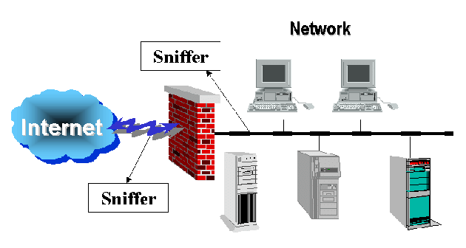
Figure 2.5 Network Sniffers
- Best Practices:
Use network sniffers in controlled environments and adhere to legal and ethical guidelines when capturing and analyzing network traffic.
Encrypt sensitive data to protect it from interception by network sniffers and other eavesdropping techniques.
Regularly update network sniffer software to patch security vulnerabilities and ensure optimal performance and compatibility.
Network sniffers play a crucial role in cybersecurity by providing visibility into network traffic, facilitating network troubleshooting, monitoring security events, and supporting forensic investigations. EduPhoenix Solutions can leverage network sniffers as part of their cybersecurity toolkit to enhance network security, detect and respond to security threats, and maintain the integrity of their network infrastructure.

2.6 Firewalls
Firewalls are essential network security devices designed to monitor and control incoming and outgoing network traffic based on predetermined security rules. They act as a barrier between internal networks (such as company networks) and external networks (such as the internet), filtering traffic to prevent unauthorized access and protect against cyber threats.
- Functionality:
Firewalls inspect network packets as they pass through the network perimeter, analyzing factors such as source and destination IP addresses, port numbers, and protocol types. Based on predefined security policies, firewalls allow or block traffic, ensuring that only legitimate and authorized communications are permitted while blocking potentially malicious or unauthorized traffic.
Firewalls can be configured to enforce security policies at different layers of the network stack, including the network layer (e.g., IP addresses), transport layer (e.g., TCP/UDP ports), and application layer (e.g., specific applications or protocols).
- Types of Firewalls:
Network Firewalls: These firewalls operate at the network layer (Layer 3) of the OSI model and examine packets based on IP addresses, port numbers, and other network-level attributes.
Application Firewalls: Also known as proxy firewalls, these firewalls operate at the application layer (Layer 7) of the OSI model and inspect traffic at the application level, providing granular control over specific applications and protocols.
Next-Generation Firewalls (NGFW): These advanced firewalls combine traditional firewall functionality with additional security features, such as intrusion prevention, application awareness, and deep packet inspection.
- Applications:
Access Control: Firewalls prevent unauthorized access to sensitive resources by enforcing access control policies and filtering inbound and outbound traffic based on predefined rules.
Threat Prevention: Firewalls protect against various cyber threats, including malware, viruses, ransomware, and denial-of-service (DoS) attacks, by blocking malicious traffic and detecting suspicious behavior.
Network Segmentation: Firewalls help segment network traffic into separate security zones, isolating critical assets and reducing the risk of lateral movement by attackers.
VPN (Virtual Private Network): Firewalls support secure remote access by acting as VPN gateways, allowing authorized users to establish encrypted connections to the corporate network from remote locations.

- Best Practices:
Regularly update firewall firmware and security policies to address emerging threats and vulnerabilities.
Implement a defense-in-depth strategy by deploying multiple layers of security controls, including firewalls, intrusion detection systems, and endpoint protection solutions.
Conduct regular firewall audits and security assessments to ensure compliance with security standards and regulations.
Monitor firewall logs and alerts for suspicious activity and security incidents, and respond promptly to mitigate potential risks.
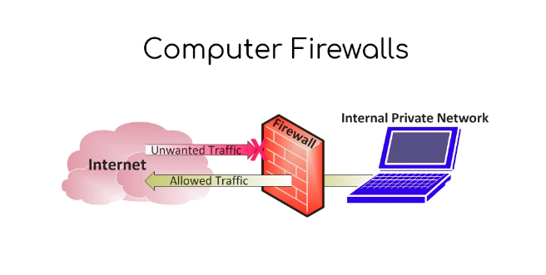
Figure 2.6 Firewall
Firewalls play a critical role in cybersecurity by safeguarding network infrastructure, protecting sensitive data, and preventing unauthorized access and cyber attacks. EduPhoenix Solutions can deploy firewalls as part of their cybersecurity strategy to create a secure network perimeter, defend against external threats, and maintain the confidentiality, integrity, and availability of their IT resources.

CHAPTER 3
INTERNSHIP TASK/DAILY-LOGS
Date | Day | Task | Detail
 | Monday | Orientation | Introduction to Cyber Security Training Program, objectives, learning outcomes, overview of domain
 | Tuesday | Introduction to Cyber Security | Importance of Cyber Security, real-world cyber incidents, need for information protection
 | Wednesday | Evolution of Cyber Security | History of Cyber Security, major cyber attacks, growth of digital threats
 | Thursday | Cyber Threat Landscape | Types of threats: malware, phishing, ransomware, DoS attacks
 | Friday | Types of Hackers | White hat, Black hat, Grey hat hackers, ethical responsibilities
 | Saturday | -------------------- | --------------------
 | Sunday | -------------------- | --------------------

Date | Day | Task | Detail
 | Monday | Basics of Computers | Hardware components, software components, role of operating systems
 | Tuesday | Networking Fundamentals | LAN, WAN, IP addressing, ports and protocols
 | Wednesday | Internet & Networking | TCP/IP model, DNS, HTTP vs HTTPS
 | Thursday | Attack Lifecycle | Phases of attack – reconnaissance, scanning, exploitation, maintaining access
 | Friday | Cyber Laws & Ethics | IT Act overview, cyber ethics, legal responsibilities in cyber space
 | Saturday | -------------------- | --------------------
 | Sunday | -------------------- | --------------------

Date | Day | Task | Detail
 | Monday | Windows Security Basics | User accounts, password policies, system updates
 | Tuesday | Windows Firewall & Protection | Firewall configuration, system security settings
 | Wednesday | Linux Basics for Security | Introduction to Linux, file system structure, basic commands
 | Thursday | Linux File Permissions | User, group, others, chmod, file access control
 | Friday | User & Access Management | Authentication, Authorization, Multi-Factor Authentication (MFA)
 | Saturday | -------------------- | --------------------
 | Sunday | -------------------- | --------------------

Date | Day | Task | Detail
 | Monday | Security Policies & Best Practices | Password policies, patch management, system updates
 | Tuesday | Backup & Data Protection | Importance of backups, data recovery concepts
 | Wednesday | Virtualization Basics | Introduction to VirtualBox, concept of virtual machines
 | Thursday | Kali Linux Introduction | Security-focused OS overview, basic navigation
 | Friday | Network Devices & Architecture | Routers, switches, firewalls, basic network structure
 | Saturday | -------------------- | --------------------
 | Sunday | -------------------- | --------------------

CHAPTER 4
PROJECT

CHAPTER 5
CAREER OPPORTUNITIES

Cyber Security offers a wide range of exciting career opportunities for individuals with skills related to cyber security. At EduPhoenix Solutions, interns are exposed to various career paths within the field of Cyber Security and are equipped with the necessary skills and knowledge to pursue these opportunities.
1. Information Security Analyst: Information security analysts are responsible for protecting an organization's computer systems and networks from cyber threats. They assess security risks, implement security measures, and monitor network activity to prevent data breaches and unauthorized access.
2. Cybersecurity Consultant: Cybersecurity consultants provide expert advice and guidance to organizations on how to improve their cybersecurity posture. They assess security vulnerabilities, develop security policies and procedures, and recommend security solutions to mitigate risks.
3. Security Architect: Security architects design and build secure IT systems and networks to protect against cyber threats. They develop security frameworks, design security controls, and ensure that security requirements are integrated into the architecture of IT systems.
4. Incident Responder: Incident responders investigate and respond to security incidents, such as data breaches, malware infections, and cyber attacks. They analyze security alerts, contain security breaches, and implement remediation measures to restore normal operations.
5. Penetration Tester (Ethical Hacker): Penetration testers (also known as ethical hackers) simulate cyber attacks to identify security vulnerabilities in IT systems and networks. They conduct vulnerability assessments, perform penetration tests, and provide recommendations for improving security defenses.
6. Security Operations Center (SOC) Analyst: SOC analysts monitor and analyze network traffic, security logs, and security alerts to detect and respond to security incidents. They investigate security breaches, escalate incidents as necessary, and coordinate incident response efforts.
7. Forensic Analyst: Forensic analysts investigate cyber crimes and security incidents by collecting and analyzing digital evidence. They use forensic tools and techniques to recover deleted files, analyze network traffic, and identify the perpetrators of cyber attacks.
8. Security Software Developer: Security software developers design and develop security software and tools to protect against cyber threats. They create antivirus programs, intrusion detection systems, encryption tools, and other security solutions to safeguard IT systems and data.
9. Compliance Analyst: Compliance analysts ensure that organizations comply with relevant cybersecurity regulations, standards, and best practices. They conduct compliance audits, assess regulatory requirements, and develop compliance programs to mitigate legal and regulatory risks.
10. Cybersecurity Trainer/Educator: Cybersecurity trainers and educators provide training and education on cybersecurity topics to individuals and organizations. They develop training materials, deliver cybersecurity courses, and raise awareness about cyber threats and security best practices.
11. Threat Intelligence Analyst: Threat intelligence analysts gather and analyze intelligence about cyber threats, including malware, phishing attacks, and hacking campaigns. They monitor threat actors, assess the risk posed by emerging threats, and provide actionable intelligence to inform security decision-making.
12. Security Operations Manager: Security operations managers oversee the day-to-day operations of a security operations center (SOC) or security team. They manage security analysts, coordinate incident response activities, and develop strategies to improve security monitoring and detection capabilities.
13. Cryptographer: Cryptographers develop cryptographic algorithms and protocols to secure communications, data storage, and transactions. They design encryption algorithms, implement cryptographic solutions, and evaluate the security of cryptographic systems.
14. Risk Analyst: Risk analysts assess and quantify the cybersecurity risks facing an organization. They conduct risk assessments, identify vulnerabilities and threats, and develop risk management strategies to mitigate risks and protect against potential losses.
15. Cybersecurity Auditor: Cybersecurity auditors evaluate the effectiveness of an organization's cybersecurity controls and practices. They conduct security audits, assess compliance with security standards and regulations, and provide recommendations for improving security posture.
16. Identity and Access Management (IAM) Specialist: IAM specialists design and implement solutions for managing user identities and controlling access to IT resources. They develop IAM policies, deploy access control mechanisms, and ensure that only authorized users have access to sensitive data and systems.
17. Security Researcher: Security researchers explore emerging threats, vulnerabilities, and attack techniques to advance the field of cybersecurity. They conduct research, publish findings, and develop new security technologies and countermeasures to address evolving cyber threats.
18. Security Awareness Trainer: Security awareness trainers educate employees and end-users about cybersecurity best practices and security awareness training programs. They develop training materials, deliver security awareness sessions, and promote a culture of security within organizations.
19. Cybersecurity Policy Analyst: Cybersecurity policy analysts analyze cybersecurity policies, regulations, and standards to ensure compliance and alignment with organizational goals. They assess policy implications, recommend policy changes, and advocate for cybersecurity policy improvements.
20. Cybersecurity Operations Specialist: Cybersecurity operations specialists manage and maintain security systems, tools, and technologies to protect against cyber threats. They configure and deploy security controls, monitor security alerts, and respond to security incidents to minimize risk and maintain operational continuity.
21. Mobile Security Analyst: Mobile security analysts specialize in securing mobile devices, applications, and platforms against cyber threats. They assess mobile security risks, develop security policies for mobile devices, and implement security controls to protect mobile infrastructure and data.
22. Cloud Security Engineer: Cloud security engineers design and implement security controls and measures to protect cloud-based infrastructure and services. They ensure the security of cloud environments, configure cloud security settings, and monitor cloud resources for security threats and vulnerabilities.
23. Industrial Control Systems (ICS) Security Specialist: ICS security specialists focus on securing industrial control systems, such as SCADA (Supervisory Control and Data Acquisition) systems and PLCs (Programmable Logic Controllers), from cyber threats. They assess ICS security risks, develop security strategies, and implement protective measures to safeguard critical infrastructure.
24. Cybersecurity Incident Manager: Cybersecurity incident managers oversee the handling and response to security incidents, such as data breaches, cyber attacks, and security breaches. They coordinate incident response efforts, manage incident response teams, and ensure timely and effective resolution of security incidents.
25. Cybersecurity Governance Analyst: Cybersecurity governance analysts develop and implement cybersecurity governance frameworks and programs to manage and mitigate cybersecurity risks. They assess organizational cybersecurity maturity, define governance policies and procedures, and establish accountability mechanisms for cybersecurity oversight and compliance.
CHAPTER 6
FUTURE TRENDS
As an intern at EduPhoenix Solutions, it's essential to stay informed about the latest trends and advancements shaping the future of Cyber Security. Here are some key trends to watch out for:
- AI and Machine Learning Integration: The integration of artificial intelligence (AI) and machine learning (ML) technologies will play a significant role in enhancing cybersecurity defenses. AI-powered systems can analyze vast amounts of data to detect and respond to cyber threats in real-time, enabling organizations to proactively identify and mitigate security risks.

- Zero Trust Architecture: Zero Trust Architecture (ZTA) is an emerging security model that assumes no trust by default, regardless of whether a user is inside or outside the corporate network. With the increasing adoption of remote work and cloud computing, ZTA will become more prevalent to prevent unauthorized access to sensitive data and resources.

- Cloud Security Solutions: As organizations continue to migrate their infrastructure and applications to the cloud, the demand for cloud security solutions will increase. Cloud security platforms and services will evolve to provide comprehensive protection against cloud-based threats, ensuring the security and privacy of data stored in the cloud.

- IoT Security: The proliferation of Internet of Things (IoT) devices presents new security challenges, as these devices often lack robust security features and are susceptible to cyber attacks. Future trends in cybersecurity will focus on improving IoT security measures to protect against emerging threats and vulnerabilities in IoT ecosystems.

- Quantum Cryptography: Quantum cryptography is a cutting-edge technology that leverages the principles of quantum mechanics to secure communications and data transmissions. As quantum computing continues to advance, quantum-resistant encryption algorithms will become essential to protect against the threat of quantum-enabled cyber attacks.

- Cyber Threat Intelligence Sharing: Collaboration and information sharing among organizations, government agencies, and cybersecurity researchers will become increasingly important for combating cyber threats. Cyber threat intelligence sharing platforms and initiatives will facilitate the exchange of threat intelligence and enable organizations to better defend against cyber attacks.
- Cyber Resilience and Incident Response: Cyber resilience strategies will focus on enhancing organizations' ability to withstand and recover from cyber attacks. Incident response plans and procedures will be refined to enable organizations to respond swiftly and effectively to security incidents, minimizing the impact on business operations and reputation.

- User Behavioral Analytics: User behavioral analytics (UBA) solutions will be used to detect anomalous behavior and potential insider threats within organizations. By analyzing user activities and behaviors, UBA platforms can identify suspicious patterns and alert security teams to potential security risks.

- Supply Chain Security: With the increasing interconnectedness of supply chains, securing the digital supply chain will become a top priority for organizations. Future trends in cybersecurity will focus on implementing supply chain security measures to prevent supply chain attacks and protect critical infrastructure and resources.

- Regulatory Compliance and Privacy Regulations: The regulatory landscape for cybersecurity will continue to evolve, with an increasing focus on data privacy and security regulations. Organizations will need to ensure compliance with existing and emerging cybersecurity regulations, such as the General Data Protection Regulation (GDPR) and the California Consumer Privacy Act (CCPA), to avoid penalties and fines for non-compliance.
These future trends in cybersecurity reflect the evolving threat landscape and the need for organizations to adapt and innovate to stay ahead of cyber threats. By embracing emerging technologies and implementing proactive cybersecurity strategies, organizations can enhance their resilience to cyber attacks and protect their valuable assets and information.

CHAPTER 7
CONCLUSION

In conclusion, the field of Cyber Security is dynamic and ever-evolving, driven by the constant advancements in technology and the evolving threat landscape. Throughout this internship at EduPhoenix Solutions, I have gained valuable insights into the critical role that Cyber Security plays in safeguarding organizations' digital assets and information from cyber threats. From learning about the fundamental principles of Cyber Security to gaining hands-on experience with various security tools and technologies, this internship has provided me with a solid foundation in Cyber Security practices and methodologies.
As organizations continue to digitalize their operations and embrace emerging technologies, the importance of Cyber Security will only grow stronger. It is imperative for organizations to prioritize Cyber Security initiatives and invest in robust security measures to protect against cyber threats, data breaches, and other security incidents. By adopting a proactive approach to Cyber Security and staying abreast of the latest security trends and best practices, organizations can mitigate risks and ensure the confidentiality, integrity, and availability of their systems and data.
Moving forward, I am excited to apply the knowledge and skills gained during this internship to contribute to the field of Cyber Security and help organizations enhance their security posture. I am confident that the experience gained at EduPhoenix Solutions has equipped me with the necessary tools and expertise to tackle the complex challenges of Cyber Security effectively.
In conclusion, Cyber Security is a critical component of modern-day business operations, and organizations must remain vigilant and proactive in addressing cybersecurity threats to safeguard their digital assets and maintain the trust of their stakeholders.
CHAPTER 8
REFERENCES
- Anderson, R., & Moore, T. (2006). Information security economics – and beyond. In Tenth Workshop on the Economics of Information Security (WEIS 2011). Retrieved from https://weis2011.econinfosec.org/papers/Anderson_WEIS2011.pdf
- BIS (Bank for International Settlements). (2019). Cyber resilience: Range of practices. Retrieved from https://www.bis.org/fsi/publ/insights20.pdf
- CERT Division, Software Engineering Institute, Carnegie Mellon University. (2020). Common vulnerabilities and exposures (CVE). Retrieved from https://cve.mitre.org/
- CIS (Center for Internet Security). (2021). CIS Controls. Retrieved from https://www.cisecurity.org/controls/
- Cisco. (2020). Cisco annual internet report (2018–2023). Retrieved from https://www.cisco.com/c/en/us/solutions/executive-perspectives/annual-internet-report/index.html
- Cloud Security Alliance. (2020). The top threats to cloud computing. Retrieved from https://cloudsecurityalliance.org/topthreats/csathreats.v1.0.pdf
- EU Agency for Cybersecurity (ENISA). (2020). Cybersecurity certification framework. Retrieved from https://www.enisa.europa.eu/publications/enisa-position-papers-and-opinions/cybersecurity-certification-framework
- Federal Trade Commission (FTC). (2020). Start with security: A guide for business. Retrieved from https://www.ftc.gov/system/files/documents/plain-language/pdf0205-startwithsecurity.pdf
- Global Cyber Alliance. (2020). Cybersecurity toolkit for small business. Retrieved from https://gcatoolkit.org/smallbusiness/
- Graham, R., & Longley, D. (2009). Information security management: Global challenges in the new millennium. In R. Hill & D. R. Maynard (Eds.), International Handbook of Personal Construct Psychology (pp. 217-230). John Wiley & Sons.
- ISO/IEC 27001:2013. (2013). Information technology – Security techniques – Information security management systems – Requirements. International Organization for Standardization.
- Kaspersky Lab. (2019). Kaspersky Security Bulletin: Statistics on cybersecurity incidents and real-world cyber threats. Retrieved from https://securelist.com/kaspersky-security-bulletin-2019-story-of-the-year/95507/
- NIST (National Institute of Standards and Technology). (2020). NIST cybersecurity framework version 1.1. Retrieved from https://www.nist.gov/cyberframework
- Ponemon Institute. (2019). Cost of a data breach study. Retrieved from https://www.ibm.com/security/data-breach
- SANS Institute. (2020). SANS 2020 cybersecurity salary and professional development survey. Retrieved from https://www.sans.org/security-resources/salary-survey/
- Schneier, B. (2015). Data and Goliath: The hidden battles to collect your data and control your world. W.W. Norton & Company.
- Symantec. (2019). Internet Security Threat Report. Retrieved from https://www.broadcom.com/company/newsroom/press-releases/2019/symantec-releases-internet-security-threat-report
- The MITRE Corporation. (2021). ATT&CK® Navigator. Retrieved from https://mitre-attack.github.io/attack-navigator/enterprise/
- The OWASP Foundation. (2020). OWASP Top 10 – 2021. Retrieved from https://owasp.org/www-project-top-ten/
- Verizon. (2020). Data breach investigations report. Retrieved from https://enterprise.verizon.com/resources/reports/dbir/
- Wireshark. (2021). Wireshark user's guide. Retrieved from https://www.wireshark.org/docs/wsug_html_chunked/
- Zeichick, A. (2015). Essential cyber security for SMEs: A guide to cyber security basics. BCS, The Chartered Institute for IT.
- Zetter, K. (2015). Countdown to zero day: Stuxnet and the launch of the world's first digital weapon. Crown.
- Dafydd, S. (2018). Understanding and quantifying the cost of ransomware. Retrieved from https://www.rapid7.com/research/report/understanding-and-quantifying-the-cost-of-ransomware/
- Harris, S. (2019). The Complete Cyber Security Course: Network Security! Retrieved from https://www.udemy.com/course/the-complete-cyber-security-course-network-security/
- ISC(2). (2020). Certified Information Systems Security Professional (CISSP). Retrieved from https://www.isc2.org/Certifications/CISSP
- Krutz, R. L., & Vines, R. D. (2019). The CISSP prep guide: Mastering the ten domains of computer security. Wiley.
- Metasploit. (2021). Metasploit unleashed. Retrieved from https://www.offensive-security.com/metasploit-unleashed/
- Raspberry Pi Foundation. (2021). Raspberry Pi Projects. Retrieved from https://www.raspberrypi.org/blog/tag/projects/
- Taylor, M., & Chapple, M. (2019). CISSP: Certified Information Systems Security Professional study guide. John Wiley & Sons.

